PROGRAM – 7

AIM: To implement Banker’s Algorithm

INTRODUCTION: The Banker’s Algorithm is a resource allocation and deadlock avoidance algorithm that tests for safety by simulating the allocation for predetermined maximum possible amounts of all resources, then makes an “s-state” check to test for possible activities, before deciding whether allocation should be allowed to continue. It consists of a safety algorithm which is used for finding out whether or not a system is in safe state. In the following program, we have tried to implement the Banker’s Algorithm in C++ on linux.

C PROGRAM :
#include <stdio.h>

int current[5][5], maximum_claim[5][5], available[5];
int processes,resources;
int need[5][5];
int counter = 0, i, j, k;
int seq[5];

void isSafe(){
for (i = 0; i < processes; ++i){
for (int j = 0; j < resources; ++j){
need[i][j] = maximum_claim[i][j] - current[i][j];
}
}

int finish[i];
for (i = 0; i < processes; ++i)
finish[i] = 0;

int work[resources];
for (i = 0; i < resources; ++i)
work[i] = available[i];

while(counter< processes){
int p;
int found = 0;
for (p = 0; p < processes; ++p){
if(finish[p] == 0){
for ( j = 0; j < resources; ++j){
if (need[p][j]>work[j]){
break;
}
}
if (j == resources){
for ( k = 0; k < resources; ++k){
work[k] += current[p][k];
}

seq[counter] = p;
counter +=1;
finish[p] = 1;
found = 1;
}
}
}

if (found == 0){
printf("\nSystem is Not in Safe State...");
return;
}
}

printf("\nSystem is in Safe State. \nSequence : ");

for (int i = 0; i < processes; ++i){
printf("P%d\t", seq[i] );
}

printf("\n");

}

int main(){

printf("\nEnter number of processes: ");
scanf("%d", &processes);

printf("\nEnter Number of resources: ");
scanf("%d", &resources);

printf("\nEnter Available resources:\n");
for (i = 0; i < resources; i++) {
printf("Resource %d : ",i);
scanf("%d", &available[i]);
}

printf("\nEnter Maximum Resources Table:\n");
for (i = 0; i < processes; i++) {
printf("Process %d : ",i );
for(j = 0; j < resources; j++) {
scanf("%d", &maximum_claim[i][j]);
}
}

printf("\nEnter Allocated Resources Table:\n");
for (i = 0; i < processes; i++){
printf("Process %d :", i );
for(j = 0; j < resources; j++) {
scanf("%d", &current[i][j]);
}
}

isSafe();

return 0;
}

OUTPUT:
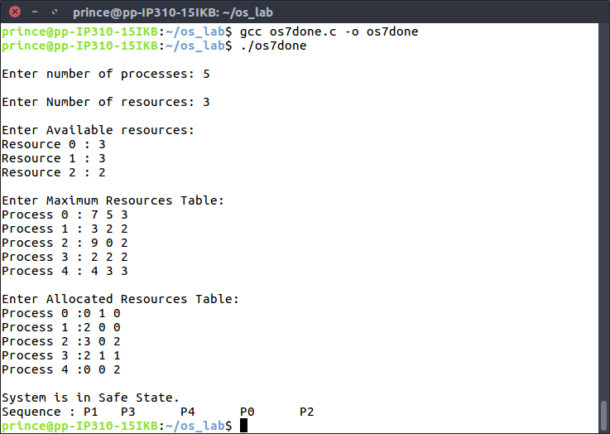
LEARNING OUTCOMES
Through the above program, we learnt about the Banker’s Algorithm and how it can be implemented to find out whether a system is in a safe state or not given the various parameters associated with the allocation and need of the resources.

